A project report on

IBM EMPLOYEE ATTRITION & PERFORMANCE -AI ML

Submitted in partial fulfillment for the award of the degree of

B.TECH

by

PAKALA DISHITHA (21BCE7471)



School of Computer Science and Engineering

June, 2024

DECLARATION

I here by declare that the report entitled “IBM EMPLOYEE ATTRITION & PERFORMANCE -AI ML” submitted by me, for the award of the degree of B.Tech VIT-AP University is a record of bonafide work carried out by me under the supervision of Dr.Baishalini Sahu.
I further declare that the work reported in this report has not been submitted and will not be submitted, either in part or in full, for the award of any other degree or diploma in this institute or any other institute or university.

Place: Amaravati 
Date: 26 -04-2024 Signature of team members

CERTIFICATE


Chapter 1
Introduction
1.1 BACKGROUND
IBM, a global technology and consulting company, has been experiencing increased employee turnover and fluctuating performance levels across different departments. Addressing these challenges is crucial for maintaining a productive and stable workforce.

1.2 OBJECTIVE
The aim of addressing employee attrition and performance is to align these efforts with broader organizational goals and values. The primary objective is to reduce employee turnover rates by implementing targeted retention strategies and addressing the factors contributing to voluntary resignations. Additionally, the goal is to retain key talent critical to the organization's success by identifying their specific needs and concerns. Enhancing overall employee satisfaction and engagement levels is also a key objective, achieved through initiatives that focus on work-life balance, career development, and fostering a positive workplace culture. By meeting these objectives, the organization intends to create a more stable and motivated workforce, driving long-term success and sustainability.

1.3 SCOPE
The scope includes data collection and analysis, predictive modeling, and the development of strategies to address attrition and performance issues. This involves collaboration across various departments and levels of the organization. This project encompasses the development of an intelligent AI tool aimed at aiding HR and operations in making informed decisions regarding employee performance and addressing attrition rates. With a focus on reducing turnover rates, retaining key talent, and enhancing overall employee satisfaction, the tool leverages machine learning algorithms to analyze employee data and identify actionable insights. By incorporating features such as performance metrics, sentiment analysis, and predictive modeling, it aims to provide comprehensive support in identifying factors contributing to attrition and strategies for employee retention. Additionally, the tool offers functionalities for monitoring and analyzing trends over time, enabling stakeholders to adapt strategies dynamically. With the potential to optimize workforce management and foster a positive organizational culture, the tool serves as a valuable asset in addressing critical HR challenges and aligning with broader organizational objectives.

Chapter 2
Data Analysis and Visualization

2.1 DATA COLLECTION
The data utilized for this project was collected from Kaggle, a prominent platform for datasets across various domains.
2.2 DATA PREPARATION

Data cleaning is the process of identifying and correcting errors, inconsistencies, and
incompleteness in a dataset. It is crucial for ensuring the accuracy and reliability of data for analysis and decision-making.
Data Understanding: (35*1500)
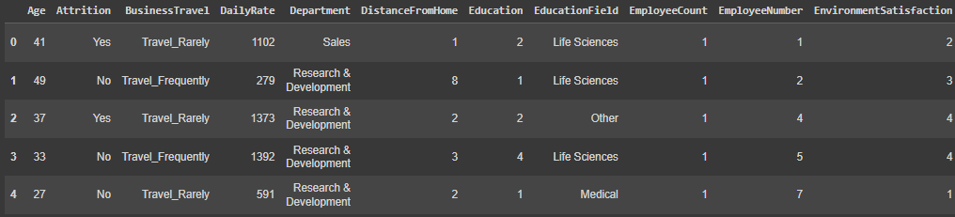
Data cleaning processes were implemented to ensure accuracy and reliability, including removing duplicates and handling missing values.

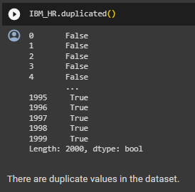
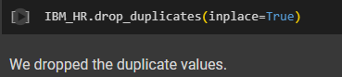
2.3 DATA VISUALIZATION
Data visualization in Power BI plays a crucial role in transforming raw data into meaningful insights and actionable information. Power BI simplifies data analysis with intuitive visualizations and advanced analytics, enabling informed decision-making and driving business success.
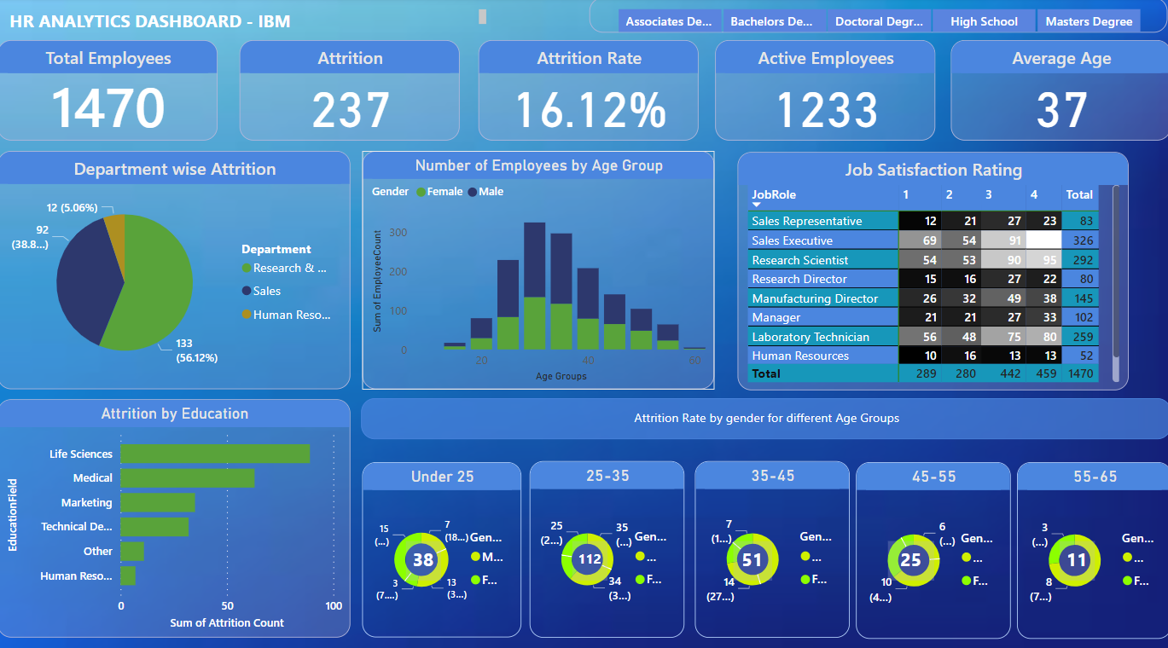

2.4 STATISTICAL ANALYSIS

Z-test, a statistical method, can be employed uniquely to identify outliers within a dataset, aiding in pinpointing data points deviating significantly from the mean and assessing their impact on overall analysis and interpretations.

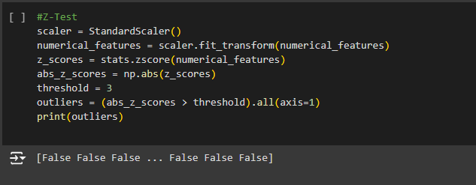
2.5 AUTO EDA
EDA was conducted using Sweetviz and AutoViz to visualize and compare datasets, identify patterns, and understand data distributions.
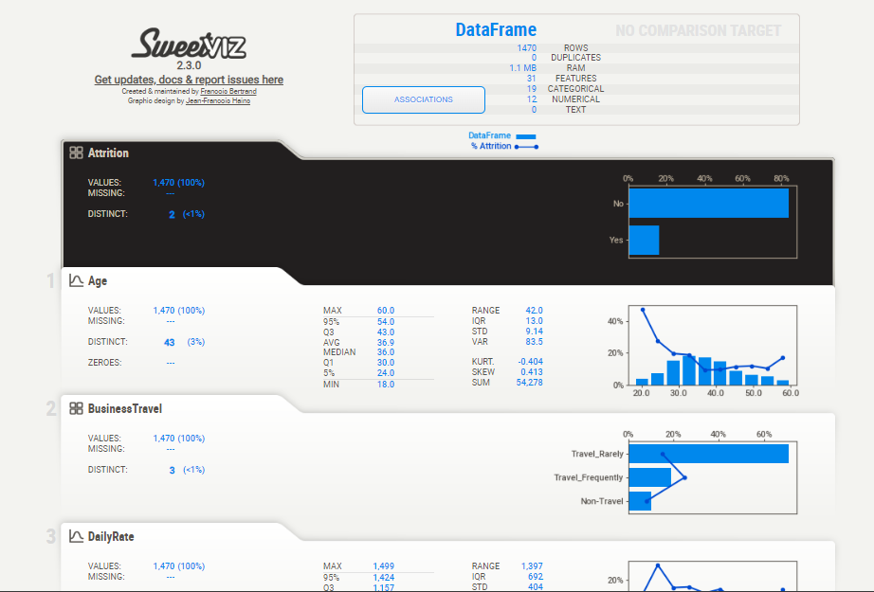

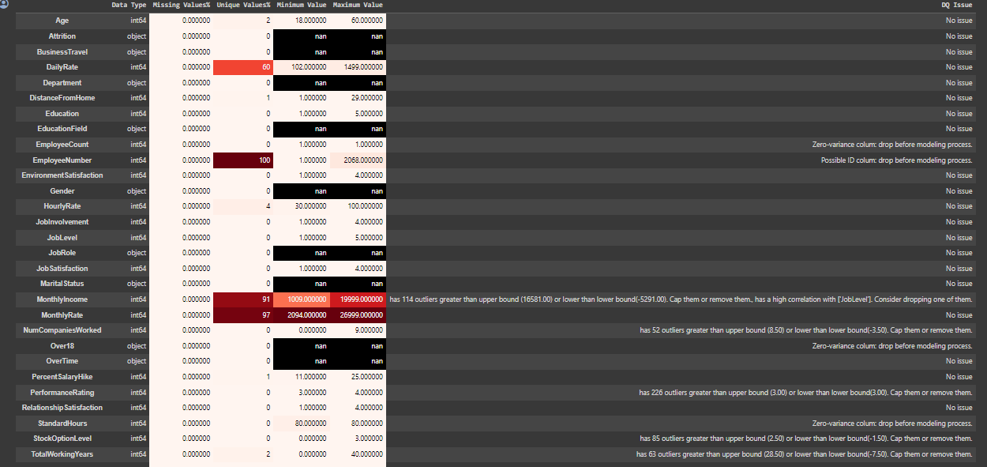

Chapter-3
Feature Selection

3.1 CORRELATION ANALYSIS
Correlation analysis was employed to assess the strength and direction of the relationship between different variables in the dataset, aiding in identifying potential predictors for the target variable and understanding the interdependencies within the data. Correlation analysis provided insights into how variables in the dataset were related to each other, highlighting potential patterns and dependencies that could influence the outcome variable. By examining correlation coefficients, such as Pearson's r, the degree of linear association between pairs of variables was evaluated, guiding feature selection and model development decisions.
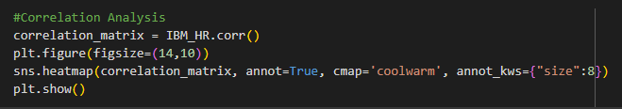
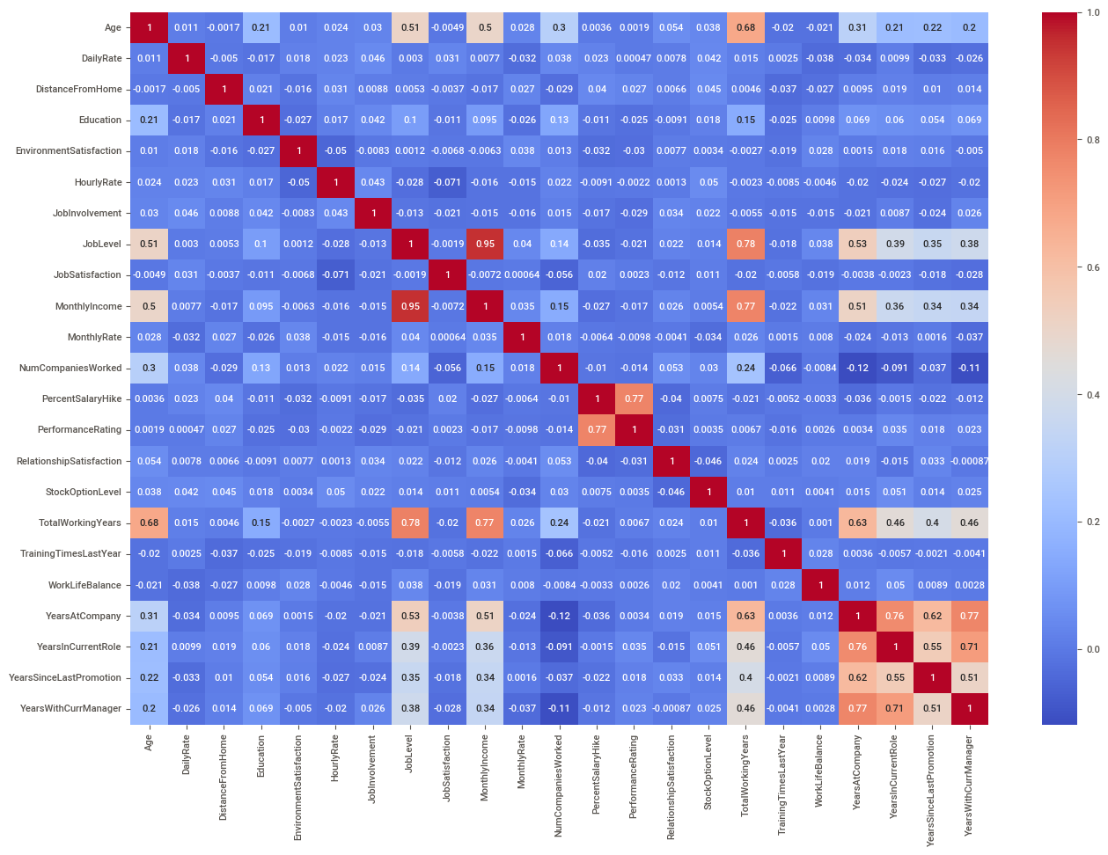
3.2 CHI-SQUARE TEST
Chi-square test assisted in determining the significance of the association between variables, aiding in feature selection for predictive modeling.
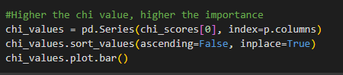
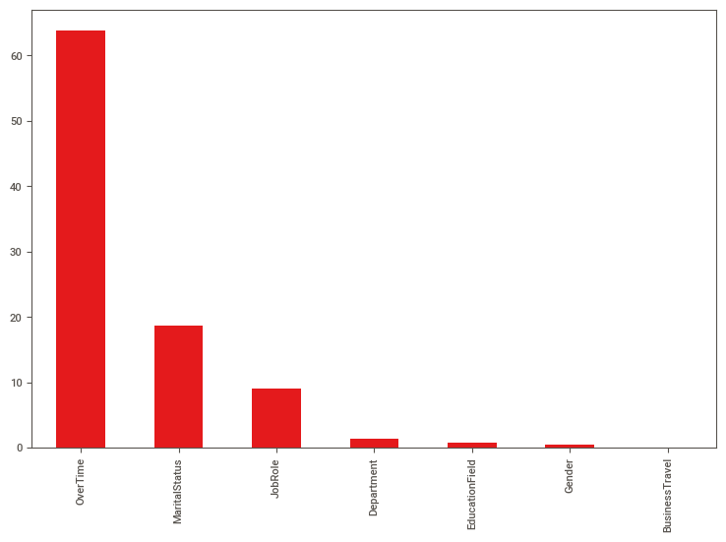
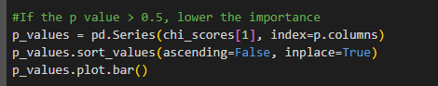
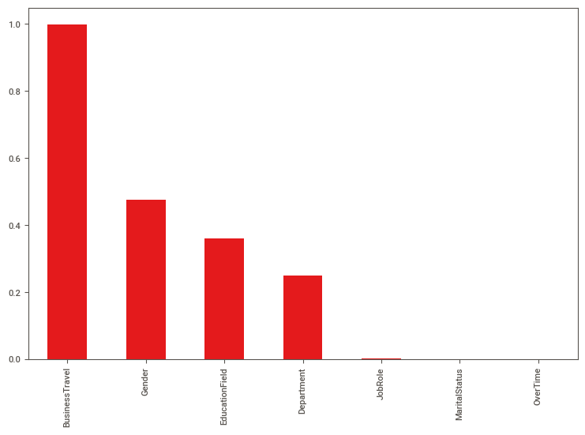

Chapter 4
Model Implementation

4.1 MODEL SELECTION
In the pursuit of developing an AI tool to address employee performance and attrition, a range of algorithms were meticulously evaluated. The assessment included logistic regression, logistic regression with L1 regularization, random forest, gradient boosting, AdaBoost, support vector machines (SVM), k-nearest neighbors (KNN), XGBoost, and various support vector regressors (SVR) such as linear, polynomial, and radial basis function (RBF) kernels. Additionally, after thorough hyperparameter tuning, further exploration was conducted with algorithms like random forest, gradient boosting, and CatBoost. Each algorithm was scrutinized for its efficacy in predicting and addressing employee behavior and outcomes, ultimately culminating in the selection of logistic regression as the most accurate and interpretable model for the given task.[3]

- Logistic Regression
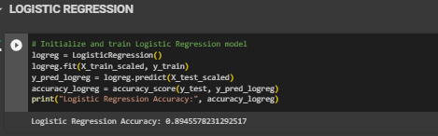

- Logistic Regression with L1 Regularization

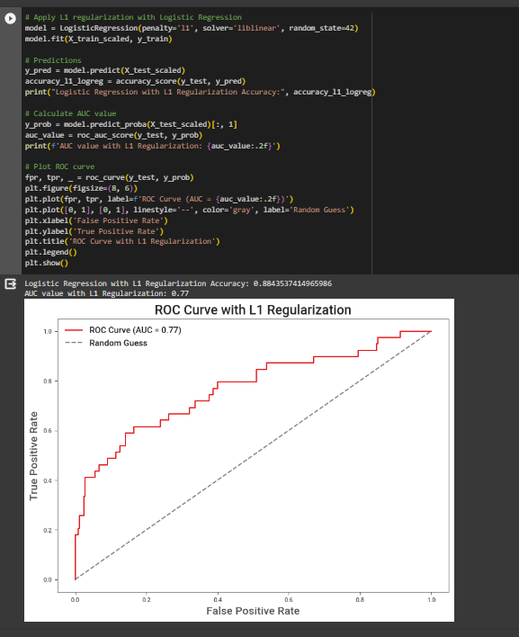

- Random Forest
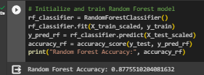

- Gradient Boosting
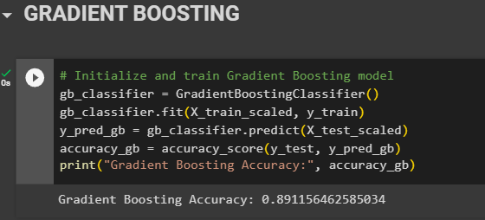

- AdaBoost
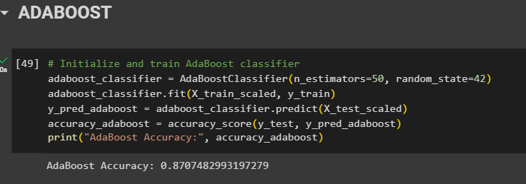

- SVM
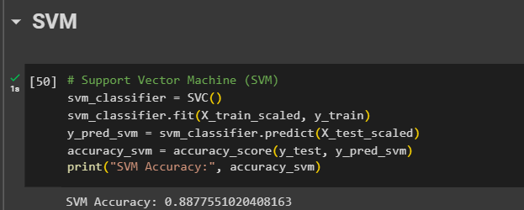

- XGBoost

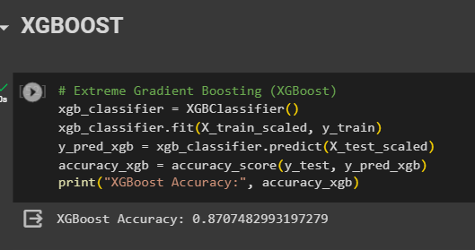

- KNN
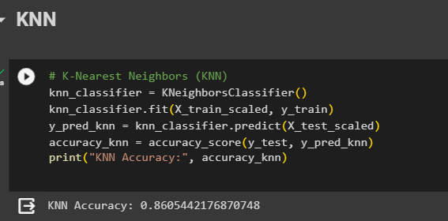

- SVR(Linear, Poly, RBF)
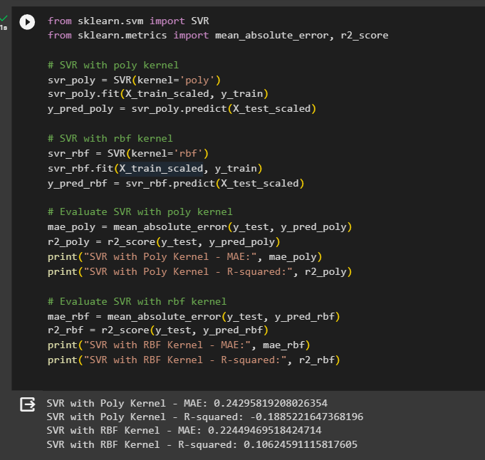

- Random Forest, Gradient Boosting, CatBoost after Hyperparameter Tuning
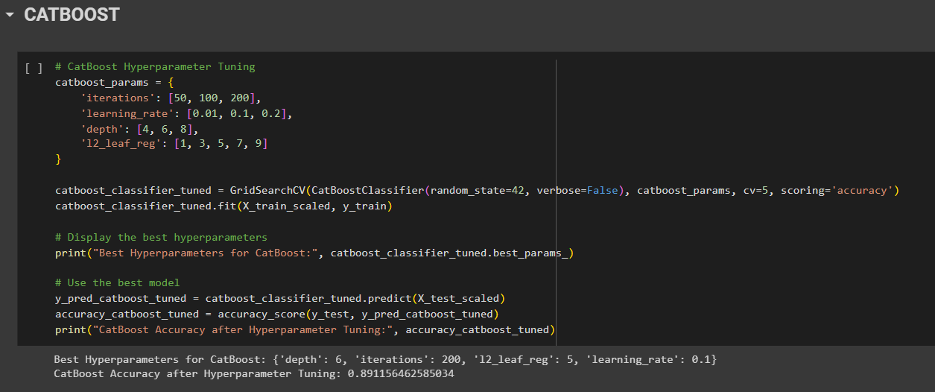

4.2 MODEL EVALUATION

K-fold cross-validation is a widely used technique in machine learning for assessing the performance and generalization ability of a model. The process involves partitioning the dataset into 'k' subsets or folds of approximately equal size. The model is trained 'k' times, each time using a different fold as the testing set and the remaining folds as the training set.

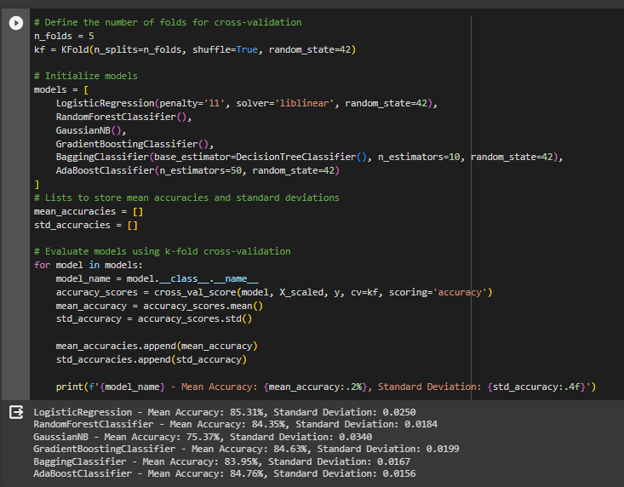

Model Comparison using ROC Curve:

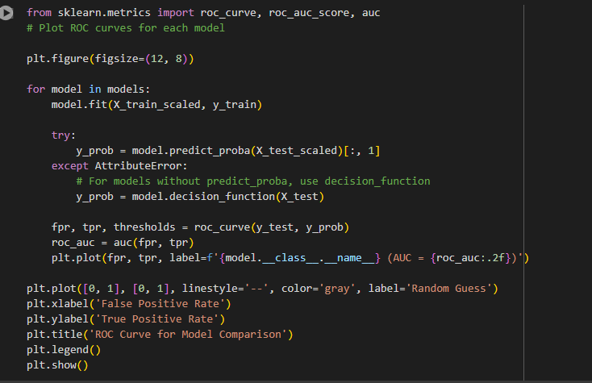

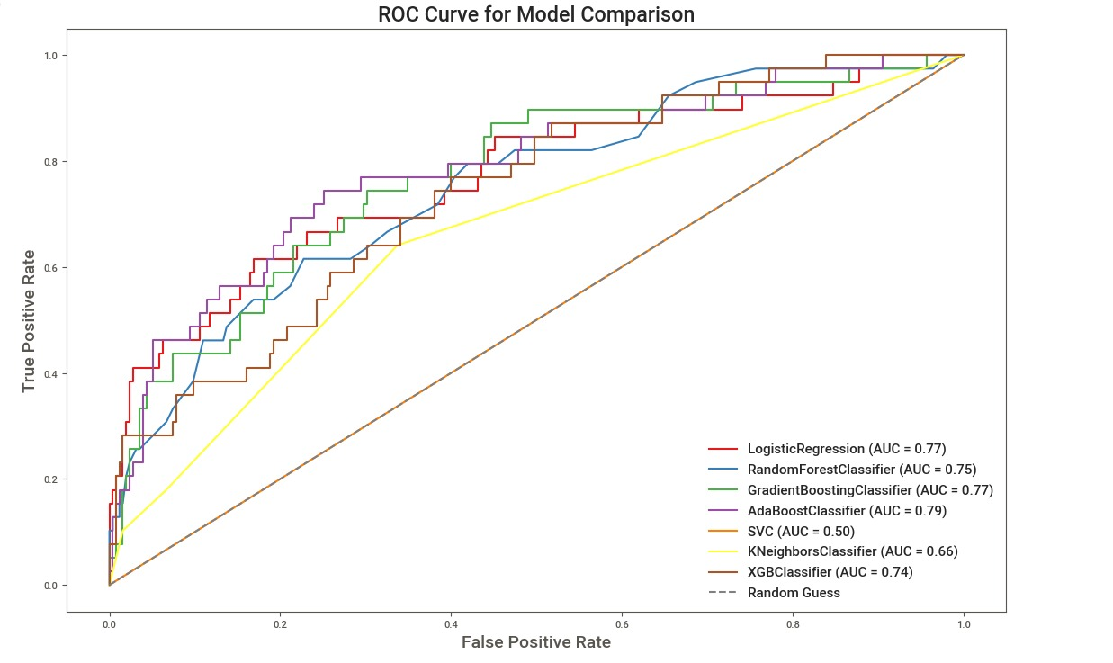

Graph on Model Accuracy Comparison:

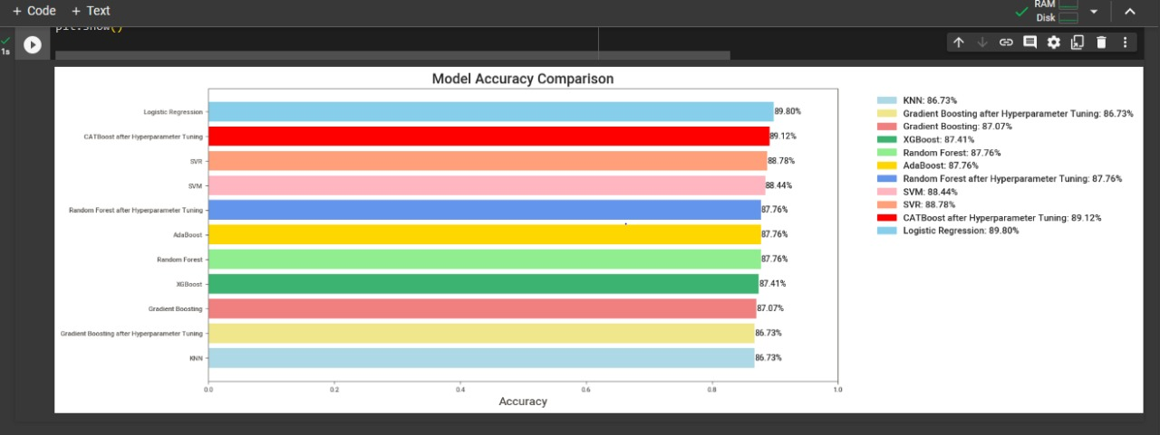

Chapter 5
Deployment

5.1 DEPLOYMENT
The best-performing models were deployed using a Flask app to predict employee attrition and assist HR in making informed decisions. The AI tool is integrated into a Flask web application, allowing HR and operations teams to access its functionalities through a user-friendly interface. Flask, a lightweight Python web framework, facilitates the development of interactive web applications, making it an ideal choice for deploying AI solutions. The Flask app is hosted on a server, ensuring accessibility to authorized users within the organization. User authentication mechanisms are implemented to secure access to sensitive employee data and ensure compliance with privacy regulations.

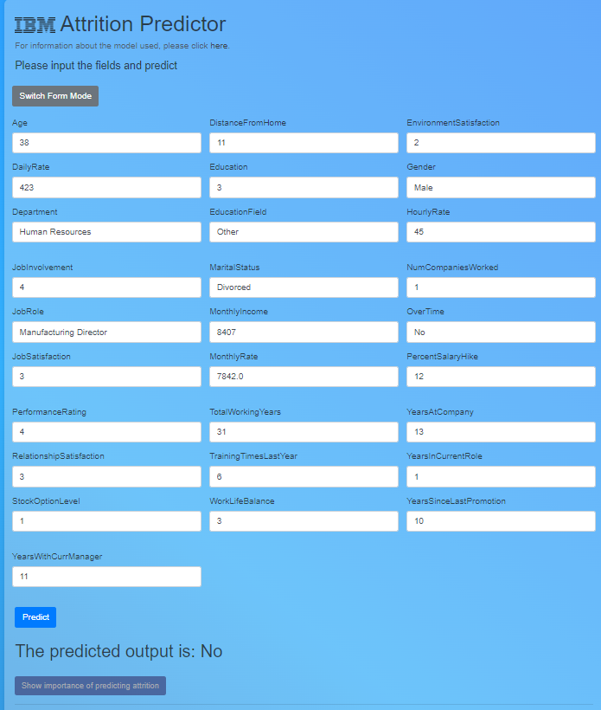
https://ibm-attrition-predictor.onrender.com/

Chapter 6
Conclusion and Future work

In conclusion, the development of the AI tool aimed at addressing employee performance and attrition has been a significant milestone in leveraging data-driven insights to enhance organizational effectiveness. By employing machine learning algorithms and predictive analytics, the tool offers HR and operations teams invaluable insights into employee behavior and performance trends, enabling proactive decision-making and targeted interventions. Throughout the project, the primary objectives of reducing turnover rates, retaining key talent, and enhancing employee satisfaction have been diligently pursued. Through the utilization of advanced analytics techniques on the provided dataset, the tool has demonstrated promising capabilities in identifying factors influencing attrition and predicting future employee performance.[6]

Moving forward, the AI tool can be enhanced by integrating additional data sources beyond Kaggle, refining predictive models, implementing real-time data analysis capabilities, improving the user interface, expanding functionalities to include talent management, incorporating a feedback mechanism for iterative development, and addressing ethical considerations. These advancements aim to provide organizations with a more comprehensive and actionable solution for managing employee performance and attrition, ultimately contributing to improved decision-making, enhanced employee satisfaction, and organizational success.
REFERENCES

Raza, A., Munir, K., Almutairi, M., Younas, F., & Fareed, M. M. S. (2022). Predicting employee attrition using machine learning approaches. Applied Sciences (Basel, Switzerland), 12(13), 6424. doi:10.3390/app12136424[1]

Géron, A. (2019). Hands-On Machine Learning with Scikit-Learn, Keras, and TensorFlow (2nd ed.). O'Reilly Media.[2]

Rao, A. S., Vardhan, B. V., & Shaik, H. (2021, July 8). Role of exploratory data analysis in data science. 2021 6th International Conference on Communication and Electronics Systems (ICCES). Presented at the 2021 6th International Conference on Communication and Electronics Systems (ICCES), Coimbatre, India. doi:10.1109/icces51350.2021.9488986[3]

Nasteski, V. (2017). An overview of the supervised machine learning methods. Horizons. b, 4(51-62), 56.[4]

Ferreira, A. J., & Figueiredo, M. A. T. (2012). Boosting algorithms: A review of methods, theory, and applications. In Ensemble Machine Learning (pp. 35–85). doi:10.1007/978-1-4419-9326-7_2[5]

Rong, S., & Bao-wen, Z. (2018). The research of regression model in machine learning field. MATEC Web of Conferences, 176, 01033. doi:10.1051/matecconf/201817601033[6]

Kotsiantis, S., Kanellopoulos, D., & Pintelas, P. (01 2006). Data Preprocessing for Supervised Learning. International Journal of Computer Science, 1, 111–117.[7]

Berrar, D. (2019). Cross-Validation. In Encyclopedia of Bioinformatics and Computational Biology (pp. 542–545). doi:10.1016/b978-0-12-809633-8.20349[8]

